Antonio Rosado

Prof. Chien

IOOP Section #4

Lab #11

**By submitting this work, I certify that this assignment is my own work, and that I have not copied in part or whole from online sources or plagiarized the work of other students.**

**8.X1**

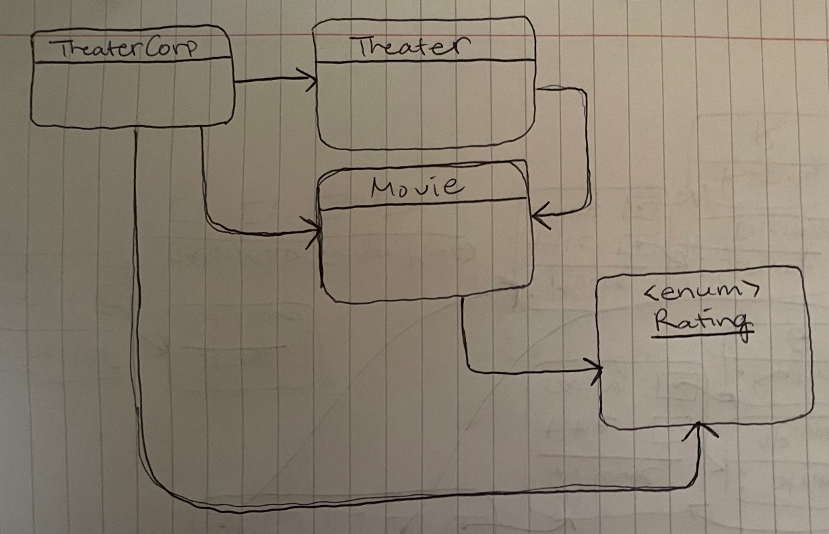

**8.X2**

**8.X3**

return myCorp.getTheaters().get(1).getLocation();

“Glassboro”

**8.X4**

return myCorp.getTheaters().get(0).getScreens().get(1).getTitle();

“Bambi”

**8.X5**

return myCorp.getTheaters().get(1).getScreens().get(1).getRatingString();

PG

**README**

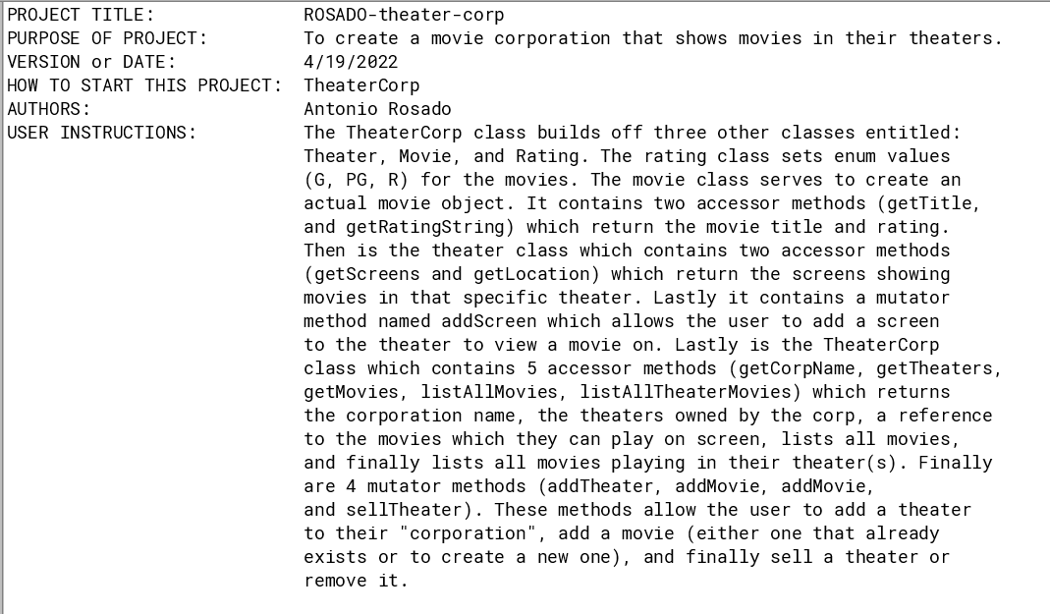

**Rating**

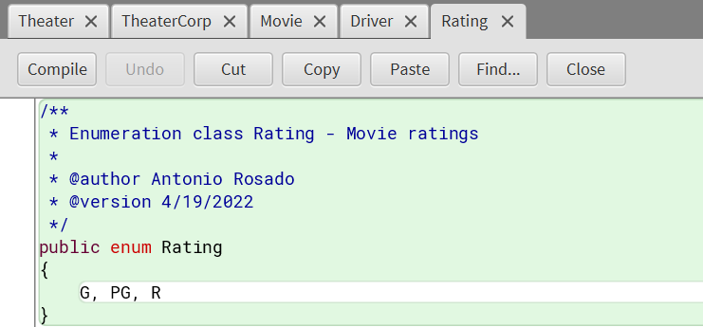

**Movie**

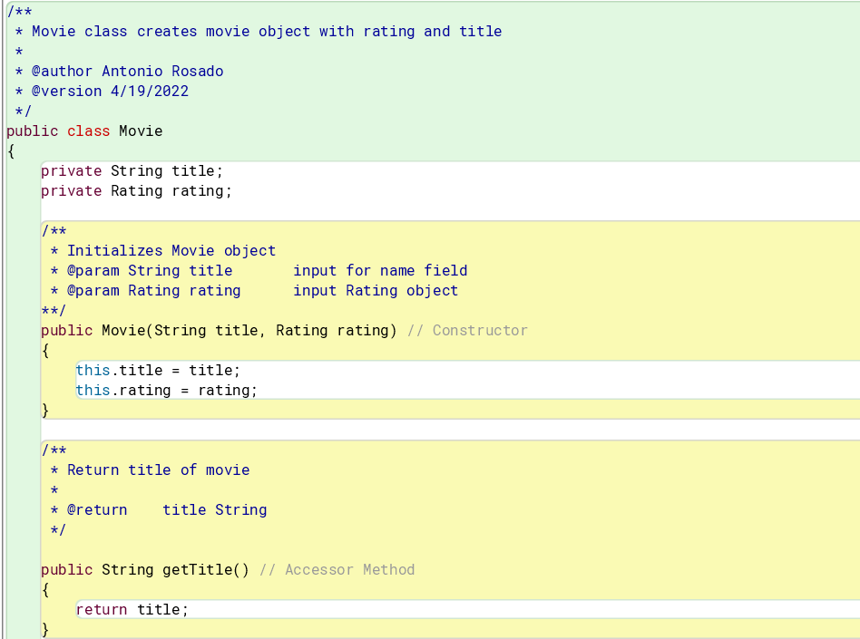

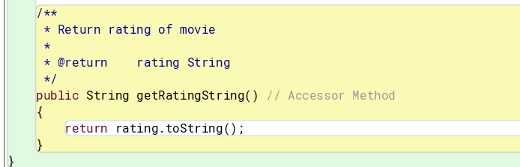

**Theater**

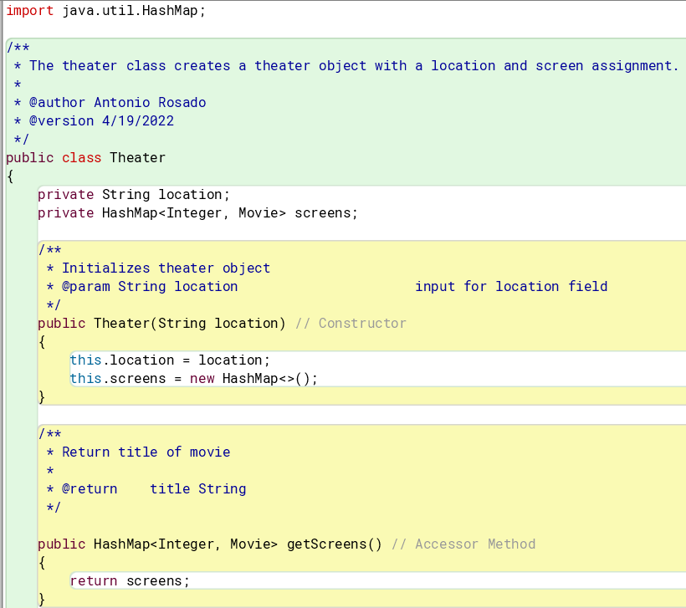

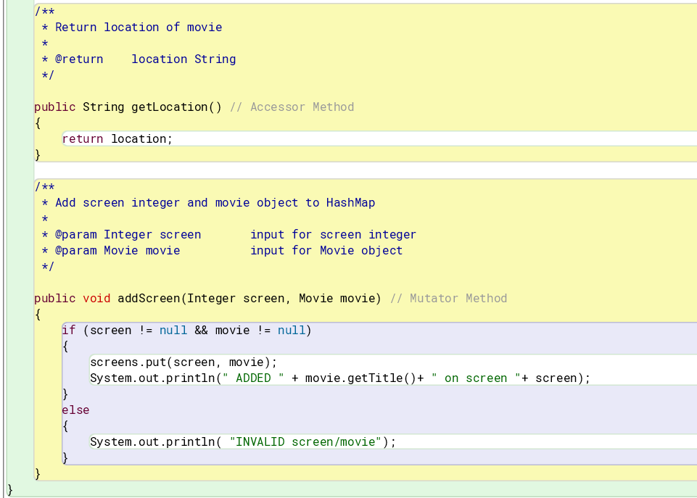

**TheaterCorp**

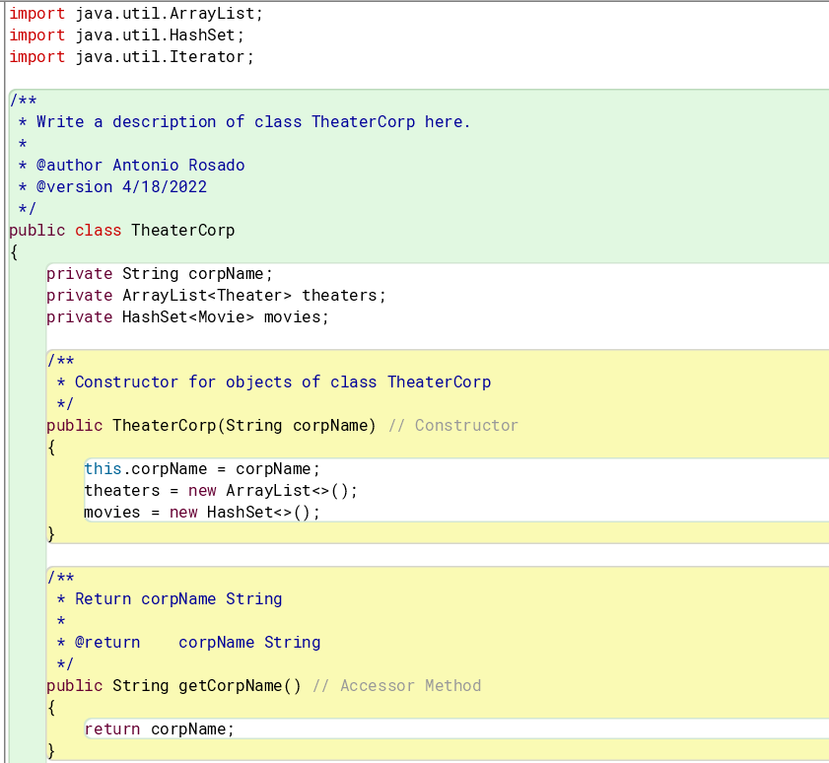

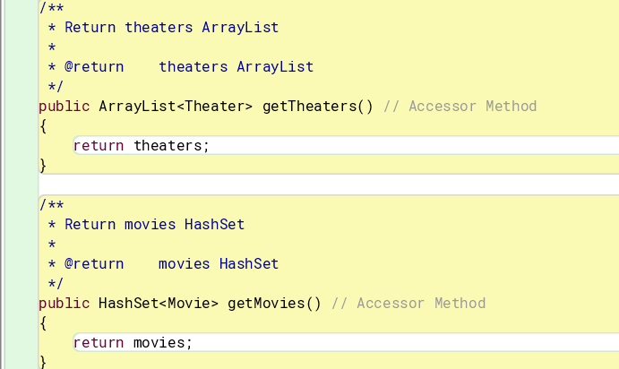

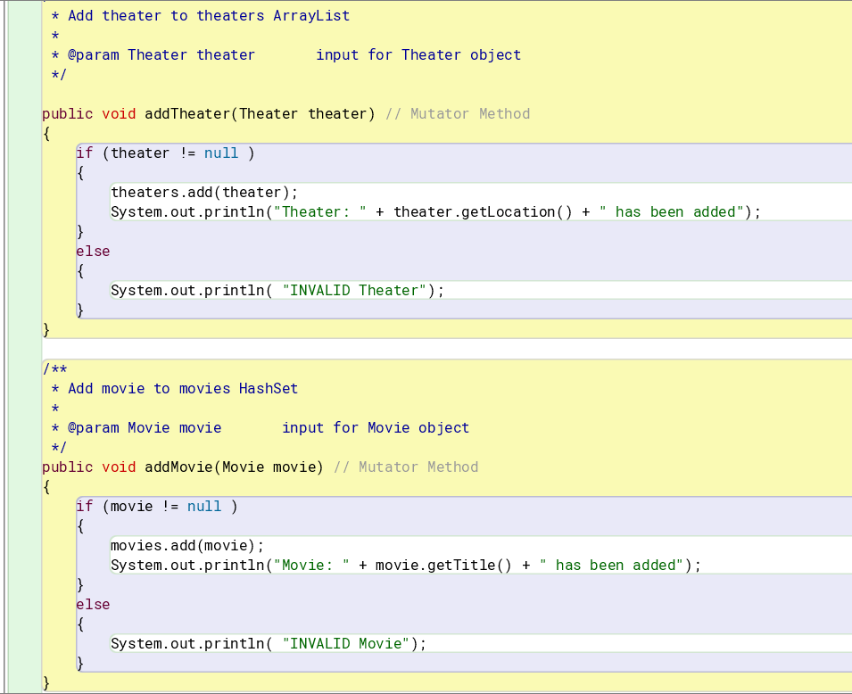

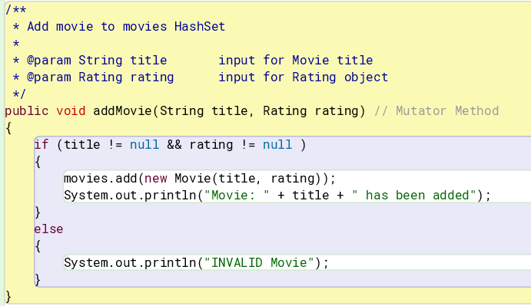

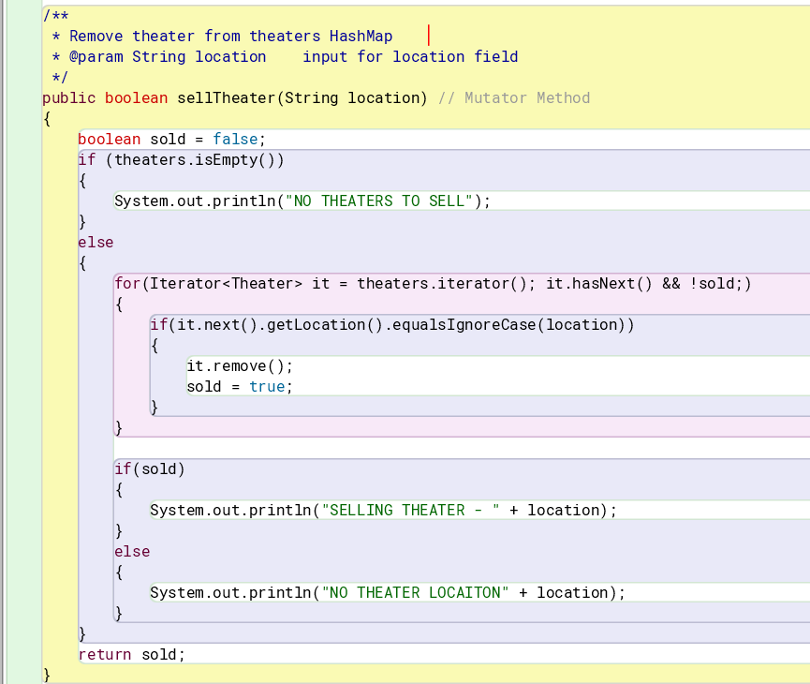

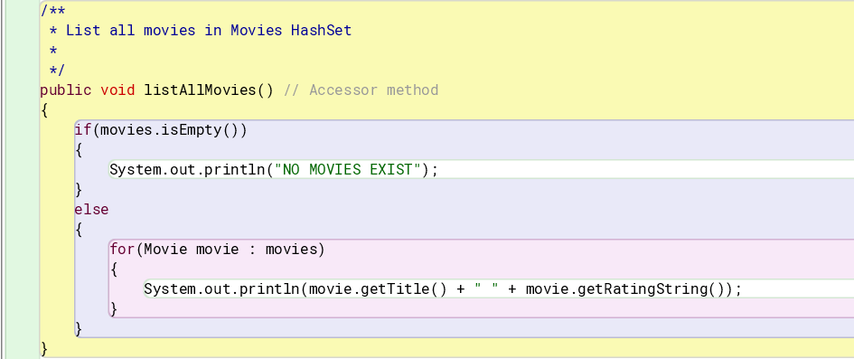

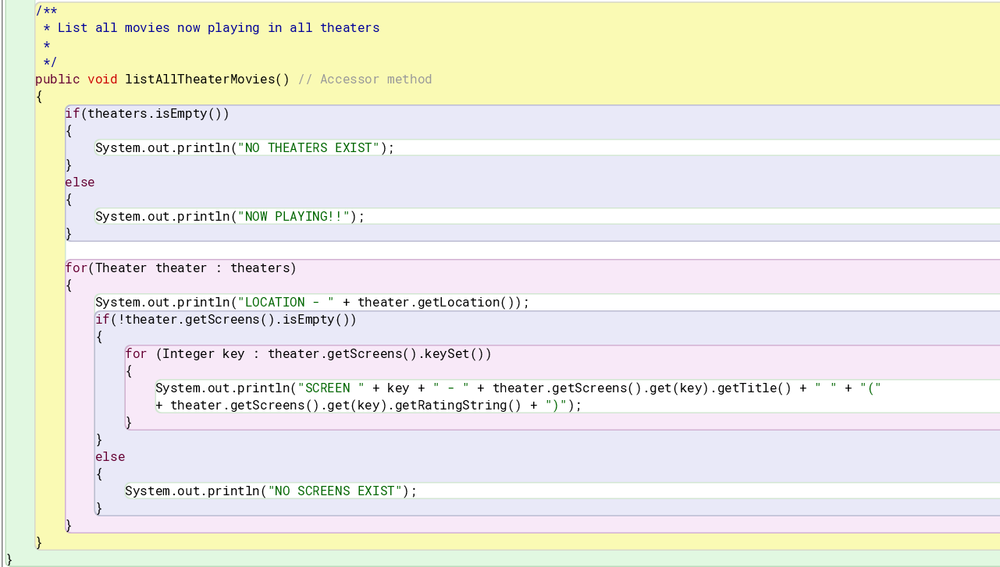

**Driver**

